Nutrition

2014 Feed Composition Table

All values except dry matter (DM) are shown on a DM basis.
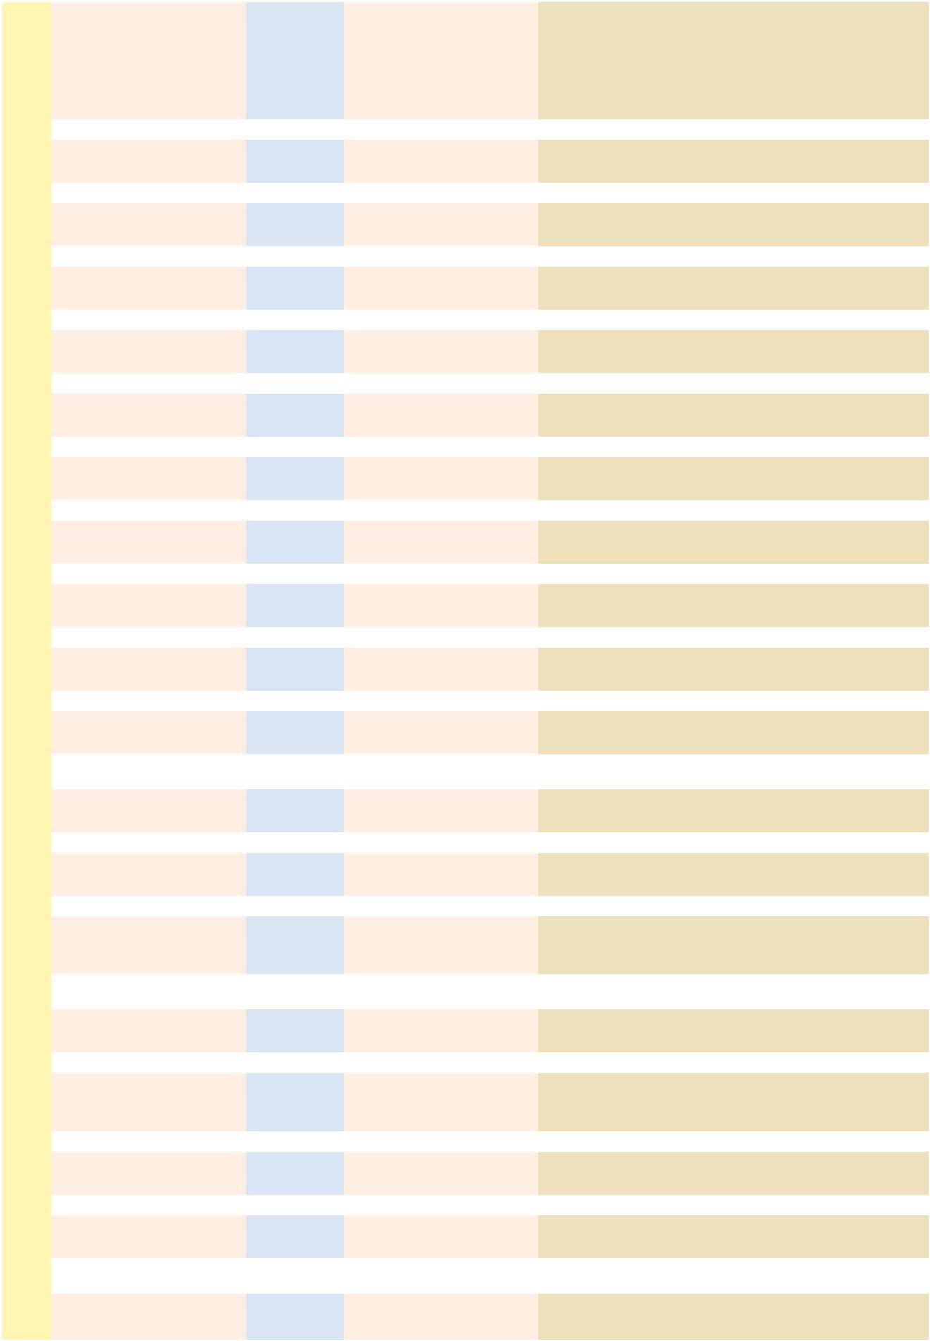

 |  |  | ENERGY |  |  |  |  | PROTEIN |  |  | FIBER
FEEDSTUFF | DM | TDN | NE_{m} |  | NE_{g} |  | NE_{l} | CP | UIP | CF | ADF | NDF | eNDF | EE | Ash | Ca | P | K | Cl | S | Zn
FEEDSTUFF | % | % |  | (Mcal/cwt.) |  |  |  | % | % | % | % | % | % | % | % | % | % | % | % | % | ppm
Alfalfa cubes | 91 | 57 | 57 |  | 25 |  | 57 | 18 | 30 | 29 | 36 | 46 | 40 | 2.0 | 11 | 1.30 | 0.23 | 1.9 | 0.37 | 0.33 | 20
Alfalfa dehydrated 17% CP | 92 | 61 | 62 |  | 31 |  | 61 | 19 | 60 | 26 | 34 | 45 | 6 | 3.0 | 11 | 1.42 | 0.25 | 2.5 | 0.45 | 0.28 | 21
Alfalfa fresh | 24 | 61 | 62 |  | 31 |  | 61 | 19 | 18 | 27 | 34 | 46 | 41 | 3.0 | 9 | 1.35 | 0.27 | 2.6 | 0.40 | 0.29 | 18
Alfalfa hay early bloom | 90 | 59 | 59 |  | 28 |  | 59 | 19 | 20 | 28 | 35 | 45 | 92 | 2.5 | 8 | 1.41 | 0.26 | 2.5 | 0.38 | 0.28 | 22
Alfalfa hay midbloom | 89 | 58 | 58 |  | 26 |  | 58 | 17 | 23 | 30 | 36 | 47 | 92 | 2.3 | 9 | 1.40 | 0.24 | 2.0 | 0.38 | 0.27 | 24
Alfalfa hay full bloom | 88 | 54 | 54 |  | 20 |  | 54 | 16 | 25 | 34 | 40 | 52 | 92 | 2.0 | 8 | 1.20 | 0.23 | 1.7 | 0.37 | 0.25 | 23
Alfalfa hay mature | 88 | 50 | 50 |  | 12 |  | 49 | 13 | 30 | 38 | 45 | 59 | 92 | 1.3 | 8 | 1.18 | 0.19 | 1.5 | 0.35 | 0.21 | 23
Alfalfa seed screenings | 91 | 84 | 92 |  | 61 |  | 87 | 34 |  | 13 | 15 |  |  | 10.7 | 6 | 0.30 | 0.67
Alfalfa silage | 30 | 55 | 55 |  | 21 |  | 55 | 18 | 19 | 28 | 37 | 49 | 82 | 3.0 | 9 | 1.40 | 0.29 | 2.6 | 0.41 | 0.29 | 26
Alfalfa silage wilted | 39 | 58 | 58 |  | 26 |  | 58 | 18 | 22 | 28 | 37 | 49 | 82 | 3.0 | 9 | 1.40 | 0.29 | 2.6 | 0.41 | 0.29 | 26
Alfalfa leaf meal | 89 | 60 | 60 |  | 30 |  | 60 | 26 | 15 | 16 | 24 | 34 | 35 | 3.0 | 10 | 2.88 | 0.34 | 2.2 |  | 0.32 | 39
Alfalfa stems | 89 | 47 | 47 |  | 7 |  | 46 | 11 | 44 | 44 | 51 | 68 | 100 | 1.3 | 6 | 0.90 | 0.18 | 2.5
Almond hulls | 89 | 56 | 56 |  | 23 |  | 56 | 3 | 60 | 16 | 29 | 36 | 100 | 3.1 | 7 | 0.24 | 0.10 | 2.0 | 0.03 | 0.07 | 20
Ammonium chloride | 99 | 0 | 0 |  | 0 |  | 0 | 163 | 0 | 0 | 0 | 0 | 0 | 0.0 |  | 0.00 | 0.00 | 0.0 | 66.00 | 0.00 | 0
Ammonium sulfate | 99 | 0 | 0 |  | 0 |  | 0 | 132 | 0 | 0 | 0 | 0 | 0 | 0.0 |  |  |  |  |  | 24.15
Apples | 17 | 70 | 73 |  | 44 |  | 71 | 3 | 10 | 7 | 9 | 25 | 10 | 2.2 | 2 | 0.06 | 0.60 | 0.8
Apple pomace wet | 20 | 68 | 70 |  | 41 |  | 69 | 5 | 10 | 18 | 27 | 36 | 27 | 5.2 | 3 | 0.13 | 0.12 | 0.5 |  | 0.04 | 11
Apple pomace dried | 89 | 67 | 69 |  | 40 |  | 68 | 5 | 15 | 18 | 28 | 38 | 29 | 5.2 | 3 | 0.13 | 0.12 | 0.5 |  | 0.04 | 11
Artichoke tops (Jerusalem) | 27 | 61 | 62 |  | 31 |  | 61 | 6 |  | 18 | 30 | 41 | 40 | 1.1 | 10 | 1.62 | 0.11 | 1.4
Avocado seed meal | 91 | 52 | 52 |  | 16 |  | 51 | 20 |  | 19 | 24 |  |  | 1.2 | 16
Bahiagrass hay | 90 | 53 | 53 |  | 18 |  | 53 | 6 | 37 | 32 | 41 | 72 | 98 | 1.8 | 7 | 0.47 | 0.20 | 1.4 |  | 0.21
Bakery product dried | 90 | 90 | 100 |  | 68 |  | 94 | 11 | 30 | 3 | 9 | 30 | 0 | 11.5 | 4 | 0.16 | 0.27 | 0.4 | 2.25 | 0.15 | 33
Bananas | 24 | 84 | 92 |  | 61 |  | 87 | 4 |  | 4 | 5 |  |  | 0.8 | 3 | 0.03 | 0.11 | 1.5 |  |  | 8
Barley hay | 90 | 57 | 57 |  | 25 |  | 57 | 9 |  | 28 | 37 | 65 | 98 | 2.1 | 8 | 0.30 | 0.28 | 1.6 |  | 0.19 | 25
Barley silage | 35 | 59 | 58 |  | 26 |  | 58 | 12 | 22 | 34 | 37 | 58 | 61 | 3.0 | 9 | 0.46 | 0.30 | 2.4 |  | 0.22 | 28
Barley silage mature | 35 | 58 | 58 |  | 26 |  | 58 | 12 | 25 | 30 | 34 | 50 | 61 | 3.5 | 9 | 0.30 | 0.20 | 1.5 |  | 0.15 | 25
Barley straw | 90 | 44 | 44 |  | 1 |  | 43 | 4 | 70 | 42 | 55 | 78 | 100 | 1.9 | 7 | 0.32 | 0.08 | 2.2 | 0.67 | 0.16 | 7
Barley grain | 89 | 84 | 92 |  | 61 |  | 87 | 12 | 28 | 5 | 7 | 20 | 34 | 2.1 | 3 | 0.06 | 0.38 | 0.6 | 0.18 | 0.16 | 23
Barley grain, steam flaked | 85 | 90 | 100 |  | 70 |  | 100 | 12 | 39 | 5 | 7 | 20 | 30 | 2.1 | 3 | 0.06 | 0.35 | 0.6 | 0.18 | 0.16 | 23
Barley grain, steam rolled | 86 | 84 | 92 |  | 61 |  | 87 | 12 | 38 | 5 | 7 | 20 | 27 | 2.1 | 3 | 0.06 | 0.41 | 0.6 | 0.18 | 0.17 | 30
Barley grain 2-row | 88 | 84 | 92 |  | 61 |  | 87 | 12 |  | 5 | 8 | 20 | 34 | 2.2 | 3 | 0.06 | 0.34 | 0.5 | 0.18 | 0.17 | 16
Barley grain 6-row | 87 | 84 | 92 |  | 61 |  | 87 | 11 |  | 6 | 8 | 20 | 34 | 2.2 | 3 | 0.05 | 0.36 | 0.5 | 0.18 | 0.15 | 14
Barley grain lt.wt. | 88 | 78 | 83 |  | 54 |  | 80 | 13 | 30 | 9 | 12 | 30 | 34 | 2.3 | 4
(42-44 lb./bu.) | 88 | 78 | 83 |  | 54
Barley feed pearl byproduct | 90 | 74 | 78 |  | 49 |  | 76 | 15 | 25 | 12 | 15 |  |  | 3.9 | 5 | 0.05 | 0.45 | 0.7 |  | 0.06
Barley bran | 91 | 59 | 59 |  | 28 |  | 59 | 12 | 28 | 21 | 27 | 36 | 6 | 4.3 | 7
Barley grain screenings | 89 | 71 | 74 |  | 46 |  | 73 | 12 |  | 9 | 11 |  |  | 2.6 | 4 | 0.35 | 0.33 | 0.9 |  | 0.15
Beans navy cull | 90 | 84 | 92 |  | 61 |  | 87 | 24 | 25 | 5 | 8 | 20 | 0 | 1.4 | 5 | 0.15 | 0.60 | 1.4 | 0.06 | 0.26 | 45
Beans pinto | 90 | 75 | 90 |  | 60 |  | 86 | 25 | 25 | 5 | 6 | 7 | 0 | 1.5 | 5 | 0.14 | 0.43 | 1.1 | 0.06 | 0.22 | 25
Beet pulp wet | 17 | 77 | 82 |  | 53 |  | 79 | 9 | 35 | 20 | 25 | 45 | 30 | 0.7 | 5 | 0.65 | 0.08 | 0.9 | 0.40 | 0.22 | 21
Beet pulp dried | 91 | 76 | 81 |  | 52 |  | 78 | 9 | 44 | 21 | 26 | 46 | 33 | 0.7 | 5 | 0.65 | 0.08 | 0.9 | 0.40 | 0.22 | 21
Beet pulp wet with | 24 | 77 | 82 |  | 53 |  | 79 | 11 | 25 | 16 | 21 | 39 | 33 | 0.6 | 6 | 0.60 | 0.10 | 1.8 |  | 0.42 | 11
molasses | 24 | 77 | 82 |  | 53 |  |  |  |  |  |  |  |  |  |  |  |  |  |  | 0.42 | 11
Beet pulp dried with | 92 | 77 | 82 |  | 53 |  | 79 | 11 | 34 | 17 | 23 | 40 | 33 | 0.6 | 6 | 0.60 | 0.10 | 1.8 |  | 0.42 | 11
molasses | 92 | 77 | 82 |  | 53 |  |  |  |  |  |  |  |  |  |  |  |  |  |  | 0.42 | 11
Beet root (sugar) | 23 | 80 | 86 |  | 56 |  | 83 | 4 |  | 5 | 7 | 16 |  | 0.4 | 3
Beet tops (sugar) | 19 | 58 | 58 |  | 26 |  | 58 | 14 |  | 11 | 14 | 25 | 41 | 1.3 | 24 | 1.10 | 0.22 | 5.2 | 0.20 | 0.45 | 20
Beet top silage | 25 | 52 | 52 |  | 16 |  | 51 | 12 |  | 12 |  |  |  | 2.0 | 32 | 1.38 | 0.22 | 5.7 |  | 0.57 | 20
Bermudagrass coastal | 90 | 62 | 63 |  | 33 |  | 63 | 16 | 40 | 26 | 29 | 40 | 10 | 3.8 | 7 | 0.40 | 0.25 | 1.8 | 0.72 | 0.23 | 18
dehydrated | 90 | 62 | 63 |  | 33
Bermudagrass coastal hay | 89 | 56 | 56 |  | 23 |  | 56 | 10 | 15 | 30 | 36 | 73 | 98 | 2.1 | 6 | 0.47 | 0.21 | 1.5 | 0.70 | 0.22 | 16
Bermudagrass hay | 89 | 53 | 53 |  | 18 |  | 53 | 10 | 15 | 29 | 37 | 72 | 98 | 1.9 | 8 | 0.46 | 0.20 | 1.5 | 0.70 | 0.25 | 31
Bermudagrass silage | 26 | 50 | 50 |  | 12 |  | 49 | 10 | 14 | 28 | 35 | 71 | 48 | 1.9 | 8 | 0.46 | 0.20 | 1.5 | 0.72 | 0.25 | 31
Birdsfoot trefoil fresh | 22 | 66 | 68 |  | 38 |  | 67 | 21 | 20 | 21 | 31 | 47 | 41 | 4.4 | 9 | 1.78 | 0.25 | 2.6 |  | 0.25 | 31
Birdsfoot trefoil hay | 89 | 57 | 57 |  | 25 |  | 57 | 16 | 22 | 31 | 38 | 50 | 92 | 2.2 | 8 | 1.73 | 0.24 | 1.8 |  | 0.25 | 28
Biuret | 99 | 0 | 0 |  | 0 |  | 0 | 248 | 0 | 0 | 0 | 0 | 0 | 0.0 | 0 | 0.00 | 0.00 | 0.0 | 0.00 | 0.00 | 0
Blood meal, swine/poultry | 91 | 66 | 68 |  | 38 |  | 67 | 92 | 82 | 1 | 2 | 10 | 0 | 1.4 | 3 | 0.32 | 0.28 | 0.2 | 0.30 | 0.70 | 22
Bluegrass KY fresh early | 36 | 69 | 71 |  | 43 |  | 70 | 15 | 20 | 27 | 32 | 60 | 41 | 3.9 | 7 | 0.37 | 0.30 | 1.9 | 0.42 | 0.19 | 25
bloom | 36 | 69 | 71 |  | 43
Bluegrass straw | 93 | 45 | 3 |  | 44 |  | 6 |  | 40 | 50 | 78 | 90 | 1.1 | 6 | 0.20 | 0.10
Bluestem fresh mature | 61 | 50 | 50 |  | 12 |  | 49 | 6 |  | 34 |  |  | 2.5 | 5 | 0.40 | 0.12 | 0.8 |  |  | 0.05 | 28

18 beefmagazine.com March 2014

Nutrition

2014 Feed Composition Table
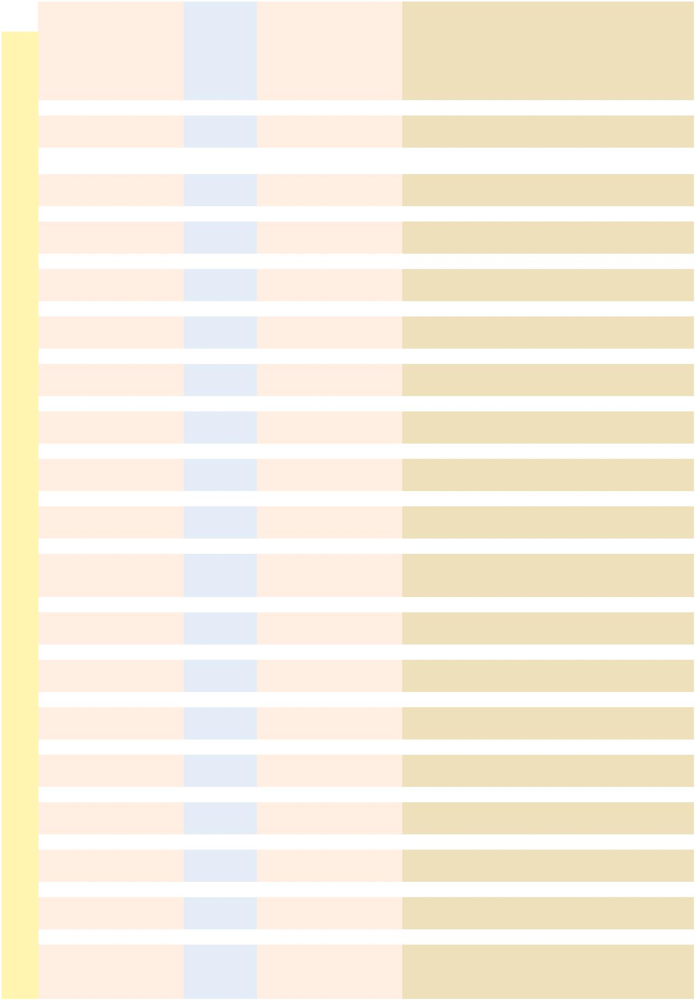

 |  |  | ENERGY |  |  |  |  | PROTEIN |  |  | FIBER
FEEDSTUFF | DM | TDN | NE_{m} |  | NE_{g} |  | NE_{l} | CP | UIP | CF | ADF | NDF | eNDF | EE | Ash | Ca | P | K | Cl | S | Zn
FEEDSTUFF | % | % |  | (Mcal/cwt.) |  |  |  | % | % | % | % | % | % | % | % | % | % | % | % | % | ppm
Bone meal steamed, swine/ | 95 | 16 | 27 |  | 0 |  | 11 | 13 |  | 1 | 0 | 0 | 0 | 11.6 | 77 | 27.00 | 12.74 | 0.2 |  | 2.50 | 290
poultry | 95 | 16 | 27 |  | 0 |  | 11 | 13 |  |  |  |  |  |  |  |  |  |  |  | 2.50 | 290
Bread byproduct | 68 | 90 | 100 |  | 68 |  | 94 | 14 | 24 | 1 | 2 | 3 | 0 | 3.0 | 3 | 0.10 | 0.18 | 0.2 | 0.76 | 0.15 | 40
Brewers grains wet | 23 | 85 | 93 |  | 62 |  | 88 | 26 | 52 | 13 | 21 | 45 | 18 | 7.5 | 4 | 0.30 | 0.58 | 0.1 | 0.15 | 0.32 | 78
Brewers grains dried | 92 | 84 | 92 |  | 61 |  | 87 | 25 | 54 | 14 | 24 | 49 | 18 | 7.5 | 4 | 0.30 | 0.58 | 0.1 | 0.15 | 0.32 | 78
Brewers yeast dried | 94 | 79 | 85 |  | 55 |  | 81 | 48 |  | 3 |  |  |  | 1.0 | 7 | 0.10 | 1.56 | 1.8 |  | 0.41 | 41
Bromegrass fresh | 30 | 64 | 65 |  | 36 |  | 65 | 15 | 12 | 28 | 33 | 54 | 40 | 4.1 | 10 | 0.45 | 0.34 | 2.3 |  | 0.21 | 20
immature | 30 | 64 | 65 |  | 36 |  |  |  |  |  |  |  |  |  |  |  |  |  |  | 0.21 | 20
Bromegrass hay | 89 | 55 | 55 |  | 21 |  | 55 | 10 | 20 | 35 | 41 | 66 | 98 | 2.3 | 9 | 0.40 | 0.23 | 1.9 | 0.40 | 0.19 | 19
Bromegrass haylage | 35 | 57 | 57 |  | 25 |  | 57 | 11 | 22 | 36 | 44 | 69 | 61 | 2.5 | 8 | 0.38 | 0.30 | 2.0 |  | 0.20 | 19
Buckwheat grain | 88 | 75 | 79 |  | 50 |  | 77 | 12 |  | 13 | 17 |  |  | 2.8 | 2 | 0.11 | 0.36 | 0.5 | 0.05 | 0.16 | 10
Buttermilk dried | 92 | 88 | 98 |  | 65 |  | 91 | 34 | 0 | 5 | 0 | 0 | 0 | 5.0 | 10 | 1.44 | 1.00 | 0.9 |  | 0.09 | 44
Cactus, prickly pear | 23 | 61 | 62 |  | 31 |  | 62 | 5 |  | 16 | 20 | 28 |  | 2.1 | 18 | 4.00 | 0.10 | 1.5 |  | 0.20
Calcium carbonate | 99 | 0 | 0 |  | 0 |  | 0 | 0 |  | 0 | 0 | 0 | 0 | 0.0 | 99 | 38.50 | 0.04 | 0.1 |  | 0.00 | 0
Canarygrass hay | 91 | 53 | 53 |  | 18 |  | 53 | 9 | 26 | 32 | 34 | 67 | 98 | 2.7 | 8 | 0.38 | 0.25 | 2.7 |  | 0.14 | 18
Canola Meal, solv. ext. | 91 | 71 | 74 |  | 46 |  | 73 | 40 | 29 | 12 | 19 | 27 | 23 | 2.7 | 8 | 0.70 | 1.12 | 1.2 | 0.07 | 0.72 | 63
Carrot pulp | 14 | 62 | 63 |  | 33 |  | 63 | 6 |  | 19 | 23 | 40 | 0 | 7.8 | 9
Carrot root fresh | 12 | 83 | 90 |  | 60 |  | 86 | 10 |  | 9 | 11 | 20 | 0 | 1.4 | 10 | 0.55 | 0.32 | 2.5 | 0.50 | 0.17
Carrot tops | 16 | 73 | 77 |  | 48 |  | 75 | 13 |  | 18 | 23 | 45 | 41 | 3.8 | 15 | 1.94 | 0.19 | 1.9
Cattle manure dried | 92 | 38 | 40 |  | 0 |  | 36 | 15 |  | 35 | 42 | 55 | 0 | 2.5 | 14 | 1.15 | 1.20 | 0.6 |  | 1.78 | 240
Cheatgrass fresh immature | 21 | 68 | 70 |  | 41 |  | 69 | 16 |  | 23 |  |  |  | 2.7 | 10 | 0.60 | 0.28
Citrus pulp dried | 90 | 78 | 83 |  | 54 |  | 80 | 7 | 38 | 13 | 20 | 21 | 33 | 2.9 | 7 | 1.81 | 0.12 | 0.8 | 0.04 | 0.08 | 14
Clover ladino fresh | 19 | 69 | 71 |  | 43 |  | 70 | 25 | 20 | 14 | 33 | 35 | 41 | 4.8 | 11 | 1.27 | 0.38 | 2.4 |  | 0.20 | 20
Clover ladino hay | 90 | 61 | 62 |  | 31 |  | 61 | 21 | 25 | 22 | 32 | 36 | 92 | 2.0 | 9 | 1.35 | 0.32 | 2.4 | 0.30 | 0.20 | 17
Clover red fresh | 24 | 64 | 65 |  | 36 |  | 65 | 18 | 21 | 24 | 33 | 44 | 41 | 4.0 | 9 | 1.70 | 0.30 | 2.0 | 0.60 | 0.17 | 23
Clover red hay | 88 | 55 | 55 |  | 21 |  | 55 | 15 | 28 | 30 | 39 | 51 | 92 | 2.5 | 8 | 1.50 | 0.25 | 1.7 | 0.32 | 0.17 | 17
Clover sweet hay | 91 | 53 | 53 |  | 18 |  | 53 | 16 | 30 | 30 | 38 | 50 | 92 | 2.4 | 9 | 1.27 | 0.25 | 1.8 | 0.37 | 0.46
Coconut meal, mech. ext. | 92 | 76 | 81 |  | 52 |  | 78 | 21 | 56 | 13 | 21 | 56 | 23 | 6.8 | 7 | 0.40 | 0.30 | 1.0 | 0.33 | 0.04
Coffee grounds | 88 | 20 | 36 |  | 0 |  | 16 | 13 |  | 41 | 68 | 77 | 10 | 15.0 | 2 | 0.10 | 0.08
Corn whole plant pelleted | 91 | 63 | 64 |  | 34 |  | 64 | 9 | 45 | 21 | 24 | 40 | 6 | 2.4 | 6 | 0.50 | 0.24 | 0.9 |  | 0.14
Corn fodder | 80 | 65 | 66 |  | 37 |  | 66 | 9 | 45 | 25 | 29 | 48 | 100 | 2.4 | 7 | 0.50 | 0.25 | 0.9 | 0.20 | 0.14
Corn stover mature (stalks) | 80 | 54 | 54 |  | 20 |  | 54 | 5 | 30 | 35 | 43 | 70 | 100 | 1.3 | 7 | 0.45 | 0.15 | 1.2 | 0.30 | 0.14 | 22
Corn silage milk stage | 26 | 65 | 66 |  | 37 |  | 66 | 8 | 18 | 26 | 32 | 54 | 60 | 2.8 | 6 | 0.40 | 0.27 | 1.6 |  | 0.11 | 20
Corn silage mature well | 34 | 72 | 75 |  | 47 |  | 74 | 8 | 28 | 21 | 27 | 46 | 70 | 3.1 | 5 | 0.28 | 0.23 | 1.1 | 0.20 | 0.13 | 22
eared | 34 | 72 | 75 |  | 47
Corn silage sweet corn | 24 | 65 | 66 |  | 37 |  | 66 | 11 |  | 20 | 32 | 57 | 60 | 5.0 | 5 | 0.24 | 0.26 | 1.2 | 0.17 | 0.16 | 39
Corn grain whole | 88 | 88 | 98 |  | 65 |  | 91 | 9 | 58 | 2 | 3 | 10 | 60 | 4.2 | 2 | 0.02 | 0.30 | 0.4 | 0.05 | 0.14 | 19
Corn grain rolled | 88 | 88 | 98 |  | 65 |  | 91 | 9 | 54 | 2 | 3 | 10 | 34 | 4.2 | 2 | 0.02 | 0.30 | 0.4 | 0.05 | 0.14 | 19
Corn grain, steam flaked | 85 | 93 | 104 |  | 71 |  | 97 | 9 | 59 | 2 | 3 | 9 | 40 | 4.1 | 2 | 0.02 | 0.27 | 0.4 | 0.05 | 0.14 | 18
Corn grain, high moisture | 74 | 93 | 104 |  | 71 |  | 97 | 10 | 42 | 2 | 3 | 9 | 0 | 4.0 | 2 | 0.02 | 0.30 | 0.4 | 0.06 | 0.14 | 20
Corn grain, high oil | 88 | 91 | 102 |  | 69 |  | 95 | 8 | 54 | 2 | 3 | 8 | 60 | 6.9 | 2 | 0.01 | 0.30 | 0.3 | 0.05 | 0.13 | 18
Corn grain hi-lysine | 92 | 87 | 96 |  | 64 |  | 90 | 12 | 58 | 4 | 4 | 11 | 60 | 4.4 | 2 | 0.03 | 0.24 | 0.4 | 0.05 | 0.11 | 18
Corn and cob meal | 87 | 82 | 89 |  | 59 |  | 85 | 9 | 52 | 9 | 11 | 26 | 56 | 3.7 | 2 | 0.06 | 0.27 | 0.5 | 0.05 | 0.13 | 16
Corn cobs | 90 | 48 | 48 |  | 9 |  | 47 | 3 | 70 | 36 | 39 | 88 | 56 | 0.6 | 2 | 0.12 | 0.04 | 0.8 |  | 0.27 | 5
Corn screenings | 87 | 87 | 96 |  | 64 |  | 90 | 9 | 52 | 3 | 4 | 10 | 20 | 3.8 | 2 | 0.04 | 0.25 | 0.3 | 0.05 | 0.11 | 16
Corn bran | 91 | 76 | 81 |  | 52 |  | 78 | 11 |  | 10 | 17 | 51 | 0 | 6.3 | 3 | 0.04 | 0.15 | 0.1 | 0.13 | 0.08 | 18
Corn germ meal | 90 | 74 | 78 |  | 49 |  | 76 | 27 | 50 | 11 | 20 | 50 | 20 | 3.0 | 3 | 0.03 | 0.46 | 0.5 | 0.03 | 0.26 | 78
Corn germ, full-fat | 93 | 135 | 198 |  | 160 |  | 198 | 12 | 55 | 6 | 11 | 36 | 20 | 44.9 | 2 | 0.02 | 0.28 | 0.1 | 0.02 | 0.17 | 60
Corn gluten feed | 90 | 80 | 86 |  | 56 |  | 83 | 23 | 28 | 10 | 12 | 37 | 36 | 3.2 | 8 | 0.14 | 0.88 | 1.2 | 0.25 | 0.55 | 80
Corn gluten meal 41% CP | 86 | 56 | 83 |  | 62 |  | 88 | 46 | 63 | 5 | 9 | 30 | 23 | 3.2 | 4 | 0.13 | 0.55 | 0.2 | 0.07 | 0.62 | 35
Corn gluten meal 60% CP | 91 | 89 | 99 |  | 67 |  | 93 | 67 | 60 | 3 | 7 | 10 | 23 | 2.4 | 4 | 0.06 | 0.51 | 0.2 | 0.10 | 0.89 | 39
Corn cannery waste | 29 | 68 | 70 |  | 41 |  | 69 | 8 | 15 | 28 | 36 | 59 | 0 | 3.0 | 5 | 0.10 | 0.29 | 1.0 |  | 0.13 | 25
Cottonseed, whole | 91 | 93 | 104 |  | 71 |  | 97 | 23 | 32 | 26 | 38 | 47 | 100 | 19.8 | 4 | 0.15 | 0.60 | 1.1 | 0.06 | 0.24 | 33
Cottonseed, whole, delinted | 90 | 95 | 107 |  | 73 |  | 99 | 24 | 39 | 19 | 28 | 40 | 100 | 22.9 | 5 | 0.12 | 0.54 | 1.2 |  | 0.22 | 36
Cottonseed, whole, extruded | 92 | 87 | 98 |  | 67 |  | 91 | 26 | 50 | 32 | 44 | 53 | 33 | 9.5 | 5 | 0.17 | 0.68 | 1.3 |  | 0.24 | 38
Cotton gin trash (burrs) | 91 | 42 | 43 |  | 0 |  | 40 | 9 |  | 35 | 50 | 70 | 100 | 2.0 | 14 | 1.40 | 0.18 | 1.9 |  | 0.14 | 25
Cottonseed hulls | 90 | 45 | 45 |  | 3 |  | 44 | 4 | 48 | 48 | 71 | 89 | 100 | 1.7 | 3 | 0.15 | 0.08 | 1.0 | 0.02 | 0.06 | 16
Cottonseed meal, solv. ext. | 90 | 77 | 82 |  | 53 |  | 79 | 46 | 42 | 13 | 20 | 28 | 23 | 1.6 | 7 | 0.21 | 1.20 | 1.6 | 0.05 | 0.44 | 71
41% CP | 90 | 77 | 82 |  | 53
Cottonseed meal, mech. ext. | 92 | 79 | 85 |  | 55 |  | 81 | 46 | 50 | 13 | 19 | 31 | 23 | 5.0 | 7 | 0.21 | 1.18 | 1.6 | 0.05 | 0.39 | 64
41% CP | 92 | 79 | 85 |  | 55

20 beefmagazine.com March 2014

Nutrition

2014 Feed Composition Table
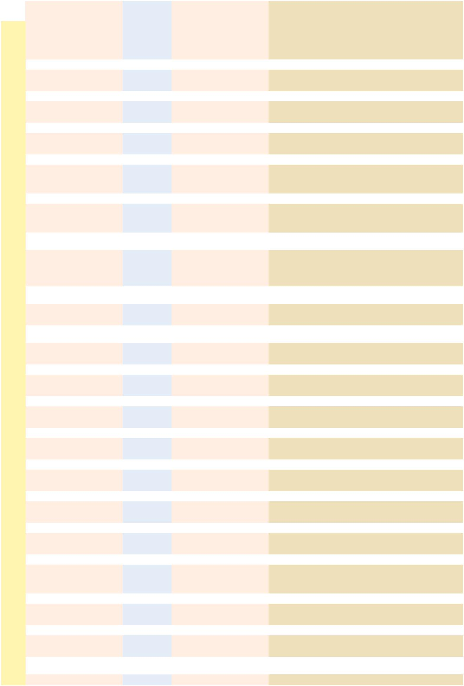

 |  |  | ENERGY |  |  |  |  | PROTEIN |  |  | FIBER
FEEDSTUFF | DM | TDN | NE_{m} |  | NE_{g} |  | NE_{l} | CP | UIP | CF | ADF | NDF | eNDF | EE | Ash | Ca | P | K | Cl | S | Zn
FEEDSTUFF | % | % |  | (Mcal/cwt.) |  |  |  | % | % | % | % | % | % | % | % | % | % | % | % | % | ppm
Crab waste meal | 91 | 29 | 37 |  | 0 |  | 30 | 32 | 65 | 11 | 13 |  |  | 3.0 | 43 | 15.00 | 1.88 | 0.5 | 1.63 | 0.27 | 107
Crambe meal, solv. ext. | 91 | 81 | 88 |  | 58 |  | 84 | 31 | 45 | 25 | 35 | 47 | 23 | 1.4 | 8 | 1.27 | 0.86 | 1.1 | 0.70 | 1.26 | 44
Crambe meal, mech. ext. | 92 | 88 | 98 |  | 65 |  | 91 | 28 | 50 | 24 | 33 | 42 | 25 | 17.0 | 7 | 1.22 | 0.78 | 1.0 | 0.65 | 1.18 | 41
Cranberry pulp meal | 88 | 49 | 49 |  | 11 |  | 48 | 7 |  | 26 | 47 | 54 | 33 | 15.7 | 2
Crawfish waste meal | 94 | 25 | 36 |  | 0 |  | 29 | 35 | 74 | 12 | 15 |  |  |  | 42 | 13.10 | 0.85
Curacao phosphate | 99 | 0 | 0 |  | 0 |  | 0 | 0 |  | 0 | 0 | 0 | 0 | 0.0 | 95 | 34.00 | 15.00
Defluorinated phosphate | 99 | 0 | 0 |  | 0 |  | 0 | 0 |  | 0 | 0 | 0 | 0 | 0.0 | 95 | 32.60 | 18.07 | 1.0 |  |  | 100
Diammonium phosphate | 98 | 0 | 0 |  | 0 |  | 0 | 115 | 0 | 0 | 0 | 0 | 0 | 0.0 | 35 | 0.52 | 20.41 | 0.0 |  | 2.16
Dicalcium phosphate | 96 | 0 | 0 |  | 0 |  | 0 | 0 |  | 0 | 0 | 0 | 0 | 0.0 | 94 | 22.00 | 18.65 | 0.1 |  | 1.00 | 70
Distillers grains, wet | 25 | 91 | 102 |  | 69 |  | 95 | 28 | 52 | 8 | 18 | 40 | 4 | 9.6 | 5 | 0.10 | 0.70 | 1.0 | 0.20 | 0.60 | 95
Distillers grain, barley | 90 | 75 | 79 |  | 50 |  | 77 | 30 | 56 | 16 | 20 | 44 | 4 | 8.5 | 4 | 0.15 | 0.67 | 1.0 | 0.18 | 0.43 | 50
Distillers grain, corn, dry | 91 | 95 | 106 |  | 72 |  | 99 | 30 | 58 | 8 | 16 | 44 | 4 | 9.5 | 4 | 0.09 | 0.75 | 0.9 | 0.14 | 0.70 | 65
Distillers grain, corn, wet | 36 | 97 | 109 |  | 74 |  | 102 | 30 | 47 | 8 | 16 | 44 | 4 | 9.5 | 4 | 0.09 | 0.75 | 0.9 | 0.14 | 0.70 | 65
Distillers grain, corn with | 90 | 92 | 103 |  | 70 |  | 96 | 29 | 55 | 9 | 17 | 38 | 4 | 10.5 | 5 | 0.21 | 0.80 | 0.9 | 0.18 | 0.70 | 86
solubles | 90 | 92 | 103 |  | 70
Distillers dried solubles | 93 | 87 | 96 |  | 64 |  | 91 | 31 | 47 | 4 | 7 | 22 | 4 | 13.0 | 8 | 0.35 | 1.20 | 1.8 | 0.28 | 1.10 | 91
Distillers corn stillage | 7 | 92 | 103 |  | 70 |  | 96 | 22 | 55 | 8 | 10 | 21 | 0 | 8.1 | 5 | 0.14 | 0.72 | 0.2 |  | 0.60 | 60
Distillers grain, sorghum, | 91 | 84 | 92 |  | 61 |  | 87 | 33 | 62 | 13 | 20 | 44 | 4 | 10.0 | 4 | 0.20 | 0.68 | 0.3 |  | 0.50 | 50
dry | 91 | 84 | 92 |  | 61 |  |  |  |  |  |  |  |  |  |  |  |  |  |  | 0.50 | 50
Distillers grain, sorghum, | 35 | 86 | 95 |  | 63 |  | 89 | 33 | 55 | 13 | 19 | 43 | 4 | 10.0 | 4 | 0.20 | 0.68 | 0.3 |  | 0.50 | 50
wet | 35 | 86 | 95 |  | 63 |  |  |  |  |  |  |  |  |  |  |  |  |  |  | 0.50 | 50
Distillers grain, sorghum | 92 | 85 | 93 |  | 62 |  | 88 | 33 | 53 | 12 | 18 | 42 | 4 | 10.0 | 4 | 0.23 | 0.70 | 0.5 |  | 0.70 | 55
with solubles | 92 | 85 | 93 |  | 62 |  |  |  |  |  |  |  |  |  |  |  |  |  |  | 0.70 | 55
Elephant (Napier) grass hay, | 92 | 55 | 55 |  | 21 |  | 54 | 9 |  | 24 | 46 | 63 | 85 | 2.0 | 10 | 0.35 | 0.30 | 1.3 |  | 0.10
chopped | 92 | 55 | 55 |  | 21 |  | 54 | 9 |  |  |  |  |  |  |  |  |  |  |  | 0.10
Fat, animal, poultry, | 99 | 195 | 285 |  | 230 |  | 285 | 0 |  | 0 | 0 | 0 | 0 | 99.0 | 0 | 0.00 | 0.00 | 0.0
vegetable | 99 | 195 | 285 |  | 230 |  | 285 | 0
Feather meal hydrolyzed | 93 | 67 | 69 |  | 40 |  | 68 | 87 | 68 | 1 | 14 | 42 | 23 | 7.0 | 3 | 0.48 | 0.45 | 0.1 | 0.20 | 1.82 | 90
Fescue KY 31 fresh | 29 | 64 | 65 |  | 36 |  | 65 | 15 | 20 | 25 | 32 | 64 | 40 | 5.5 | 9 | 0.48 | 0.37 | 2.5 |  | 0.18 | 22
Fescue KY 31 hay early | 88 | 60 | 60 |  | 30 |  | 60 | 18 | 22 | 25 | 31 | 64 | 98 | 6.6 | 8 | 0.48 | 0.36 | 2.6 |  | 0.27 | 24
bloom | 88 | 60 | 60 |  | 30 |  |  |  |  |  |  |  |  |  |  |  |  |  |  | 0.27 | 24
Fescue KY 31 hay mature | 88 | 52 | 52 |  | 16 |  | 51 | 11 | 26 | 30 | 42 | 73 | 98 | 5.0 | 6 | 0.45 | 0.26 | 1.7 |  | 0.14 | 22
Fescue (red) straw | 94 | 43 | 44 |  | 0 |  | 41 | 4 |  | 41 |  |  |  | 1.1 | 6 | 0.00 | 0.06
Fish meal | 90 | 74 | 78 |  | 49 |  | 76 | 66 | 60 | 1 | 2 | 12 | 10 | 9.0 | 20 | 5.55 | 3.15 | 0.7 | 0.76 | 0.80 | 130
Flax seed hulls | 91 | 38 | 40 |  | 0 |  | 36 | 9 |  | 32 | 39 | 50 | 98 | 1.5 | 10
Garbage municipal cooked | 23 | 80 | 86 |  | 56 |  | 83 | 16 |  | 9 | 50 | 59 | 30 | 20.0 | 10 | 1.20 | 0.43 | 0.6 | 0.67
Glycerol (glycerin) | 88 | 90 | 100 |  | 68 |  | 94 | 0 | 0 | 0 | 0 | 0 | 0 | 0.0 | 6 |  |  |  | 4.00
Grain screenings | 90 | 65 | 66 |  | 37 |  | 66 | 14 |  | 14 |  |  |  | 5.5 | 9 | 0.25 | 0.34 |  |  |  | 30
Grain dust | 92 | 73 | 77 |  | 48 |  | 75 | 10 |  | 11 |  |  |  | 2.2 | 10 | 0.30 | 0.18 |  |  |  | 42
Grape pomace stemless | 91 | 40 | 42 |  | 0 |  | 38 | 12 | 45 | 32 | 46 | 54 | 34 | 7.6 | 9 | 0.55 | 0.07 | 0.6 | 0.01 |  | 24
Grass hay | 88 | 58 | 58 |  | 26 |  | 58 | 10 | 30 | 33 | 41 | 63 | 98 | 3.0 | 6 | 0.60 | 0.21 | 2.0 |  | 0.20 | 28
Grass silage | 30 | 61 | 62 |  | 31 |  | 61 | 11 | 24 | 32 | 39 | 60 | 61 | 3.4 | 8 | 0.70 | 0.24 | 2.1 |  | 0.22 | 29
Guar meal | 90 | 72 | 75 |  | 47 |  | 74 | 39 | 34 | 16 |  |  |  | 3.9 | 5
Hominy feed | 89 | 89 | 99 |  | 67 |  | 93 | 11 | 48 | 6 | 7 | 19 | 9 | 5.8 | 2 | 0.03 | 0.48 | 0.5 | 0.06 | 0.12 | 27
Hop leaves | 37 | 49 | 49 |  | 11 |  | 48 | 15 |  | 15 |  |  |  | 3.6 | 35 | 2.80 | 0.64
Hop vine silage | 30 | 53 | 53 |  | 18 |  | 53 | 15 |  | 21 | 24 |  |  | 3.1 | 20 | 3.30 | 0.37 | 1.8 |  | 0.22 | 44
Hops spent | 89 | 35 | 39 |  | 0 |  | 33 | 23 |  | 26 | 30 |  |  | 4.6 | 7 | 1.60 | 0.60
Kelp dried | 91 | 32 | 38 |  | 0 |  | 29 | 7 |  | 7 | 10 |  |  | 0.5 | 39 | 2.72 | 0.31
Kenaf hay | 92 | 48 | 48 |  | 9 |  | 47 | 10 |  | 31 | 44 | 56 | 98 | 2.9 | 12
Kochia fresh | 29 | 55 | 55 |  | 21 |  | 55 | 16 |  | 23 |  |  |  | 1.2 | 18 | 1.10 | 0.30
Kochia hay | 90 | 53 | 53 |  | 18 |  | 53 | 14 |  | 27 |  |  |  | 1.7 | 14 | 1.00 | 0.20
Kudzu hay | 90 | 54 | 54 |  | 20 |  | 54 | 16 |  | 33 |  |  |  | 2.6 | 7 | 3.00 | 0.23
Lespedeza fresh early | 25 | 60 | 60 |  | 30 |  | 60 | 16 | 50 | 32 |  |  |  | 2.0 | 10 | 1.20 | 0.24 | 1.1 |  | 0.21
bloom | 25 | 60 | 60 |  | 30 |  |  |  |  |  |  |  |  |  |  |  |  |  |  | 0.21
Lespedeza hay | 92 | 54 | 54 |  | 20 |  | 54 | 14 | 60 | 30 |  |  |  | 3.0 | 7 | 1.10 | 0.22 | 1.0 |  | 0.19 | 29
Limestone ground | 98 | 0 | 0 |  | 0 |  | 0 | 0 | 0 | 0 | 0 | 0 | 0 | 0.0 | 98 | 34.00 | 0.02 |  |  | 0.03
Limestone dolomitic ground | 99 | 0 | 0 |  | 0 |  | 0 | 0 | 0 | 0 | 0 | 0 | 0 | 0.0 | 98 | 22.30 | 0.04 | 0.4
Linseed meal, solv. ext. | 91 | 77 | 82 |  | 53 |  | 79 | 39 | 36 | 10 | 17 | 26 | 23 | 1.9 | 7 | 0.43 | 0.91 | 1.5 | 0.04 | 0.52 | 65
Linseed meal, mech. ext. | 91 | 82 | 89 |  | 59 |  | 85 | 37 | 40 | 10 | 17 | 24 | 23 | 6.0 | 6 | 0.42 | 0.90 | 1.4 | 0.04 | 0.46 | 59
Meadow hay | 90 | 50 | 50 |  | 12 |  | 49 | 7 | 23 | 33 | 44 | 70 | 98 | 2.5 | 9 | 0.61 | 0.18 | 1.6 |  | 0.17 | 24
Meat meal, swine/poultry | 93 | 71 | 74 |  | 46 |  | 73 | 56 | 64 | 2 | 7 | 48 | 0 | 10.5 | 24 | 9.00 | 4.42 | 0.5 | 1.27 | 0.48 | 190
Meat and bone meal, swine/ | 93 | 72 | 75 |  | 47 |  | 74 | 56 | 24 | 1 | 5 | 34 | 0 | 10.0 | 29 | 13.50 | 6.50
poultry | 93 | 72 | 75 |  | 47
Milk, dry, skim | 94 | 87 | 96 |  | 64 |  | 90 | 36 | 0 | 0 | 0 | 0 | 0 | 0.9 | 8 | 1.36 | 1.09 | 1.7 | 0.96 | 0.34 | 41

22 beefmagazine.com March 2014

Nutrition

2014 Feed Composition Table
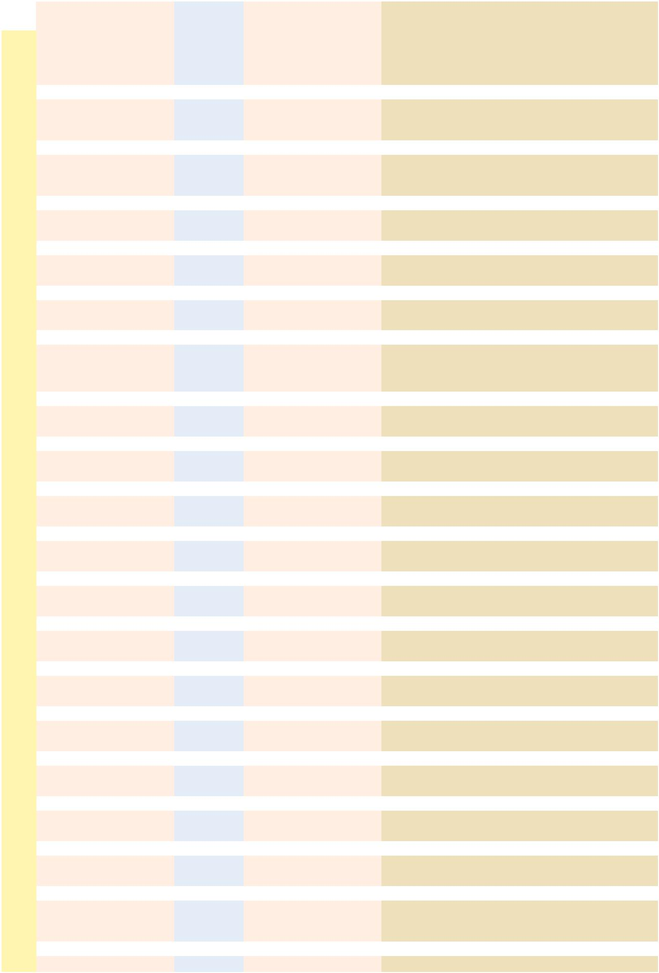

 |  |  | ENERGY |  |  |  |  | PROTEIN |  |  | FIBER
FEEDSTUFF | DM | TDN | NE_{m} |  | NE_{g} |  | NE_{l} | CP | UIP | CF | ADF | NDF | eNDF | EE | Ash | Ca | P | K | Cl | S | Zn
FEEDSTUFF | % | % |  | (Mcal/cwt.) |  |  |  | % | % | % | % | % | % | % | % | % | % | % | % | % | ppm
Mint slug silage | 27 | 55 | 55 |  | 21 |  | 55 | 14 |  | 24 |  |  |  | 1.8 | 16 | 1.10 | 0.57
Molasses beet | 77 | 75 | 79 |  | 50 |  | 77 | 8 | 0 | 0 | 0 | 0 | 0 | 0.2 | 12 | 0.14 | 0.03 | 6.0 | 1.64 | 0.60 | 18
Molasses cane | 77 | 74 | 78 |  | 49 |  | 76 | 6 | 0 | 0 | 0 | 0 | 0 | 0.5 | 14 | 0.95 | 0.09 | 4.2 | 2.30 | 0.68 | 15
Molasses cane dried | 94 | 74 | 78 |  | 49 |  | 76 | 9 | 0 | 2 | 3 | 7 | 0 | 0.3 | 14 | 1.10 | 0.15 | 3.6 | 3.00 |  | 30
Molasses, cond. fermenta- | 43 | 69 | 71 |  | 43 |  | 70 | 16 | 0 | 0 | 0 | 0 | 0 | 1.0 | 26 | 2.12 | 0.14 | 7.5 | 2.73 | 0.93 | 30
tion solubles | 43 | 69 | 71 |  | 43
Molasses citrus | 65 | 75 | 79 |  | 50 |  | 77 | 9 | 0 | 0 | 0 | 0 | 0 | 0.3 | 8 | 1.84 | 0.15 | 0.2 | 0.11 | 0.23 | 137
Molasses wood, hemicel- | 61 | 70 | 73 |  | 44 |  | 71 | 1 | 0 | 1 | 2 | 4 | 0 | 0.6 | 7 | 1.10 | 0.10 | 0.1 |  | 0.05
lulose | 61 | 70 | 73 |  | 44 |  |  |  |  |  |  |  |  |  |  |  |  |  |  | 0.05
Monoammonium phosphate | 98 | 0 | 0 |  | 0 |  | 0 | 70 | 0 | 0 | 0 | 0 | 0 | 0.0 | 24 | 0.30 | 24.70 | 0.0 |  | 1.42 | 81
Mono-Dicalcium phosphate | 97 | 0 | 0 |  | 0 |  | 0 | 0 |  | 0 | 0 | 0 | 0 | 0.0 | 94 | 16.70 | 21.10 | 0.1 |  | 1.20 | 70
Oat hay | 90 | 54 | 54 |  | 20 |  | 54 | 10 | 25 | 31 | 39 | 63 | 98 | 2.3 | 8 | 0.40 | 0.27 | 1.6 | 0.42 | 0.21 | 28
Oat silage | 35 | 60 | 60 |  | 30 |  | 60 | 12 | 21 | 31 | 39 | 59 | 61 | 3.2 | 10 | 0.34 | 0.30 | 2.4 | 0.50 | 0.25 | 27
Oat straw | 91 | 48 | 48 |  | 9 |  | 47 | 4 | 40 | 41 | 48 | 73 | 98 | 2.3 | 8 | 0.24 | 0.07 | 2.5 | 0.78 | 0.22 | 6
Oat grain | 89 | 76 | 81 |  | 52 |  | 78 | 13 | 18 | 11 | 15 | 28 | 34 | 5.0 | 4 | 0.05 | 0.41 | 0.5 | 0.11 | 0.20 | 40
Oat grain, steam flaked | 84 | 88 | 98 |  | 65 |  | 91 | 13 | 26 | 11 | 15 | 30 | 32 | 4.9 | 4 | 0.05 | 0.37 | 0.5 | 0.11 | 0.20 | 40
Oat groats | 91 | 91 | 102 |  | 69 |  | 95 | 18 | 15 | 3 |  |  |  | 6.6 | 2 | 0.08 | 0.47 | 0.4 | 0.10 | 0.20
Oat middlings | 90 | 91 | 102 |  | 69 |  | 95 | 16 | 20 | 4 | 6 |  |  | 6.0 | 3 | 0.07 | 0.48 | 0.5 |  | 0.23
Oat mill byproduct | 89 | 33 | 38 |  | 0 |  | 30 | 7 |  | 27 | 37 |  |  | 2.4 | 6 | 0.13 | 0.22 | 0.6 |  | 0.24
Oat hulls | 93 | 38 | 40 |  | 0 |  | 36 | 4 | 25 | 33 | 41 | 75 | 90 | 1.6 | 7 | 0.16 | 0.15 | 0.6 | 0.08 | 0.14 | 31
Orange pulp dried | 89 | 79 | 85 |  | 55 |  | 81 | 9 |  | 9 | 16 | 20 | 33 | 1.8 | 4 | 0.71 | 0.11 | 0.6 |  | 0.05
Orchardgrass fresh early | 24 | 65 | 66 |  | 37 |  | 66 | 14 | 23 | 30 | 32 | 54 | 41 | 4.0 | 9 | 0.33 | 0.39 | 2.7 | 0.08 | 0.20 | 21
bloom | 24 | 65 | 66 |  | 37
Orchardgrass hay | 88 | 59 | 59 |  | 28 |  | 59 | 10 | 27 | 34 | 40 | 67 | 98 | 3.3 | 8 | 0.32 | 0.30 | 2.6 | 0.41 | 0.20 | 26
Pea vine hay | 89 | 59 | 59 |  | 28 |  | 59 | 11 |  | 32 | 50 | 62 | 92 | 2.0 | 7 | 1.25 | 0.24 | 1.3 |  | 0.20 | 20
Pea vine silage | 25 | 58 | 58 |  | 26 |  | 58 | 16 |  | 29 | 44 | 55 | 61 | 3.3 | 8 | 1.25 | 0.28 | 1.6 |  | 0.29 | 32
Pea vine straw | 89 | 51 | 51 |  | 14 |  | 50 | 7 |  | 41 | 49 | 72 | 98 | 1.4 | 7 | 0.75 | 0.13 | 1.1 |  | 0.15
Peas cull | 88 | 85 | 93 |  | 62 |  | 88 | 23 | 22 | 7 | 9 | 12 | 0 | 1.4 | 4 | 0.14 | 0.46 | 1.1 | 0.06 | 0.26 | 30
Peanut hulls | 91 | 22 | 36 |  | 0 |  | 18 | 7 |  | 63 | 65 | 74 | 98 | 1.5 | 5 | 0.20 | 0.07 | 0.9
Peanut meal, solv. ext. | 91 | 77 | 82 |  | 53 |  | 79 | 51 | 27 | 9 | 16 | 27 | 23 | 2.5 | 6 | 0.26 | 0.62 | 1.1 | 0.03 | 0.30 | 38
Peanut skins | 92 | 0 | 0 |  | 0 |  | 0 | 17 |  | 13 | 20 | 28 | 0 | 22.0 | 3 | 0.19 | 0.20
Pearl millet grain | 87 | 82 | 89 |  | 59 |  | 85 | 13 |  | 2 | 6 | 18 | 34 | 4.5 | 3 | 0.03 | 0.36 | 0.5
Pineapple greenchop | 17 | 47 | 47 |  | 7 |  | 46 | 8 |  | 24 | 35 | 64 | 41 | 2.4 | 7 | 0.28 | 0.08
Pineapple bran | 89 | 71 | 74 |  | 46 |  | 73 | 5 |  | 20 | 33 | 66 | 20 | 1.5 | 3 | 0.26 | 0.12
Pineapple presscake | 21 | 71 | 74 |  | 46 |  | 73 | 5 |  | 24 | 35 | 69 | 20 | 0.8 | 3 | 0.25 | 0.09
Potato vine silage | 15 | 59 | 59 |  | 28 |  | 59 | 15 |  | 26 |  |  |  | 3.7 | 19 | 2.10 | 0.29 | 4.0 |  | 0.37
Potatoes cull | 21 | 80 | 86 |  | 56 |  | 83 | 10 | 0 | 2 | 3 | 4 | 0 | 0.4 | 5 | 0.03 | 0.24 | 2.2 | 0.30 | 0.09
Potato waste wet | 14 | 82 | 89 |  | 59 |  | 85 | 7 | 0 | 9 | 11 | 18 | 0 | 1.5 | 3 | 0.16 | 0.25 | 1.2 | 0.36 | 0.11 | 12
Potato waste dried | 89 | 85 | 93 |  | 62 |  | 88 | 8 | 0 | 7 | 9 | 15 | 0 | 0.5 | 5 | 0.16 | 0.25 | 1.2 | 0.39 | 0.11 | 12
Potato waste wet with lime | 17 | 80 | 86 |  | 56 |  | 83 | 5 | 0 | 10 | 12 | 16 | 0 | 0.3 | 9 | 4.20 | 0.18
Potato waste filter cake | 14 | 77 | 82 |  | 53 |  | 79 | 5 | 0 | 2 |  |  |  | 7.7 | 3 | 0.10 | 0.19 | 0.2
Poultry byproduct meal | 93 | 79 | 85 |  | 55 |  | 81 | 62 | 49 | 2 |  |  |  | 14.5 | 17 | 4.00 | 2.25 | 0.5 | 0.58 | 0.56 | 129
Poultry manure dried | 89 | 38 | 40 |  | 0 |  | 36 | 28 | 22 | 13 | 15 | 35 | 0 | 2.1 | 33 | 10.20 | 2.80 | 2.3 | 1.05 | 0.20 | 520
Prairie hay | 91 | 50 | 50 |  | 12 |  | 49 | 7 | 30 | 34 | 47 | 67 | 98 | 2.0 | 8 | 0.40 | 0.15 | 1.1 | 0.06 | 0.06 | 34
Pumpkins, cull | 11 | 80 | 86 |  | 56 |  | 83 | 15 |  | 14 | 21 | 30 | 0 | 8.9 | 9 | 0.24 | 0.43 | 3.3
Rice straw | 91 | 40 | 42 |  | 0 |  | 38 | 4 |  | 38 | 47 | 72 | 100 | 1.4 | 13 | 0.23 | 0.08 | 1.2 |  | 0.11
Rice straw ammoniated | 87 | 45 | 45 |  | 3 |  | 44 | 9 |  | 39 | 53 | 68 | 100 | 1.3 | 12 | 0.25 | 0.08 | 1.1 |  | 0.11
Rice grain | 89 | 79 | 85 |  | 55 |  | 81 | 8 | 30 | 10 | 12 | 16 | 34 | 1.9 | 5 | 0.07 | 0.32 | 0.4 | 0.09 | 0.05 | 17
Rice polishings | 90 | 90 | 100 |  | 68 |  | 94 | 14 |  | 4 | 5 |  |  | 14.0 | 9 | 0.05 | 1.34 | 1.2 | 0.12 | 0.19 | 28
Rice bran | 91 | 71 | 74 |  | 46 |  | 73 | 14 | 30 | 13 | 18 | 24 | 0 | 16.0 | 11 | 0.07 | 1.70 | 1.8 | 0.09 | 0.19 | 40
Rice hulls | 92 | 13 | 35 |  | 0 |  | 8 | 3 | 45 | 44 | 70 | 81 | 90 | 0.9 | 20 | 0.12 | 0.07 | 0.5 | 0.08 | 0.08 | 24
Rice mill byproduct | 91 | 39 | 41 |  | 0 |  | 37 | 7 |  | 32 | 50 | 60 | 0 | 5.7 | 19 | 0.25 | 0.48 | 2.2 |  | 0.30 | 31
Rye grass hay | 90 | 58 | 58 |  | 26 |  | 58 | 10 | 30 | 33 | 38 | 65 | 98 | 3.3 | 8 | 0.45 | 0.30 | 2.2 |  | 0.18 | 27
Rye grass silage | 32 | 59 | 59 |  | 28 |  | 59 | 14 | 25 | 22 | 37 | 59 | 61 | 3.3 | 8 | 0.43 | 0.38 | 2.9 | 0.73 | 0.23 | 29
Rye straw | 89 | 44 | 44 |  | 1 |  | 43 | 4 |  | 44 | 55 | 71 | 100 | 1.5 | 6 | 0.24 | 0.09 | 1.0 | 0.24 | 0.11
Rye grain | 89 | 80 | 86 |  | 56 |  | 83 | 14 | 20 | 3 | 9 | 19 | 34 | 2.5 | 3 | 0.07 | 0.55 | 0.5 | 0.03 | 0.17 | 33
Safflower meal, solv. ext. | 91 | 56 | 56 |  | 23 |  | 56 | 24 |  | 33 | 41 | 57 | 36 | 1.3 | 6 | 0.35 | 0.79 | 0.9 | 0.21 | 0.23 | 65
Safflower meal dehulled, | 91 | 75 | 79 |  | 50 |  | 77 | 47 |  | 11 | 20 | 27 | 30 | 0.8 | 7 | 0.38 | 1.50 | 1.2 | 0.18 | 0.22 | 36
solv. ext. | 91 | 75 | 79 |  | 50 |  | 77 | 47
Safflower hulls | 91 | 14 | 35 |  | 0 |  | 34 | 4 |  | 58 | 73 | 90 | 100 | 3.7 | 2
Sagebrush fresh | 50 | 50 | 50 |  | 12 |  | 49 | 13 |  | 25 | 30 | 38 |  | 9.2 | 10 | 1.00 | 0.25 |  |  | 0.22
Sanfoin hay | 88 | 61 | 62 |  | 31 |  | 62 | 14 | 60 | 24 |  |  |  | 3.1 | 9

24 beefmagazine.com March 2014

Nutrition

2014 Feed Composition Table
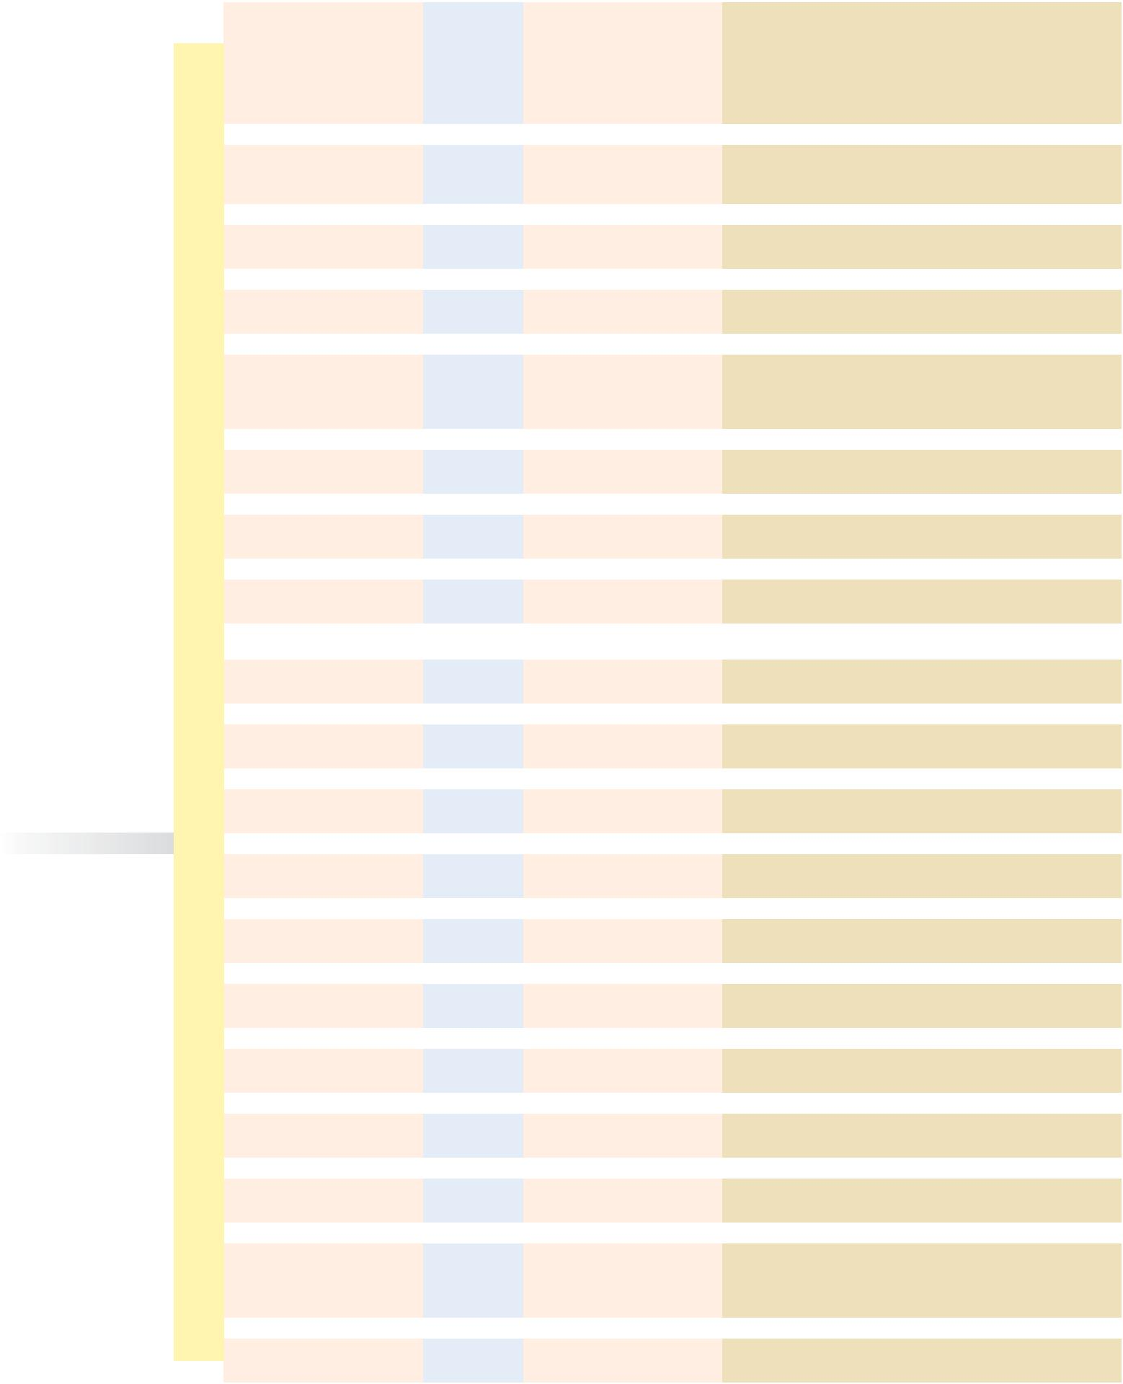

 |  |  | ENERGY |  |  |  |  | PROTEIN |  |  | FIBER
FEEDSTUFF | DM | TDN | NE_{m} |  | NE_{g} |  | NE_{l} | CP | UIP | CF | ADF | NDF | eNDF | EE | Ash | Ca | P | K | Cl | S | Zn
FEEDSTUFF | % | % |  | (Mcal/cwt.) |  |  |  | % | % | % | % | % | % | % | % | % | % | % | % | % | ppm
Shrimp waste meal | 90 | 48 | 48 |  | 9 |  | 47 | 50 | 60 | 11 |  |  |  | 5.5 | 25 | 8.50 | 1.75 |  | 1.15
Sodium tripolyphosphate | 96 | 0 | 0 |  | 0 |  | 0 | 0 |  | 0 | 0 | 0 | 0 | 0.0 | 96 | 0.00 | 25.98 | 0.0 |  | 0.00
Sorghum stover | 87 | 54 | 54 |  | 20 |  | 54 | 5 |  | 33 | 41 | 65 | 100 | 1.8 | 10 | 0.50 | 0.12 | 1.2
Sorghum silage | 32 | 59 | 59 |  | 28 |  | 59 | 9 | 25 | 27 | 38 | 59 | 70 | 2.7 | 6 | 0.48 | 0.21 | 1.7 | 0.45 | 0.11 | 30
Sorghum grain (milo) | 89 | 82 | 89 |  | 59 |  | 85 | 11 | 55 | 3 | 7 | 17 | 5 | 3.1 | 2 | 0.03 | 0.32 | 0.4 | 0.10 | 0.12 | 17
ground | 89 | 82 | 89 |  | 59
Sorhum grain (milo) flaked | 82 | 90 | 100 |  | 68 |  | 94 | 11 | 62 | 3 | 7 | 17 | 38 | 3.1 | 2 | 0.03 | 0.28 | 0.4 | 0.10 | 0.12 | 17
Soybean hay | 89 | 52 | 52 |  | 16 |  | 51 | 16 |  | 33 | 40 | 55 | 92 | 3.5 | 8 | 1.28 | 0.29 | 1.0 | 0.15 | 0.24 | 24
Soybean straw | 88 | 42 | 43 |  | 0 |  | 40 | 5 |  | 44 | 54 | 70 | 100 | 1.4 | 6 | 1.59 | 0.06 | 0.6 |  | 0.26
Soybeans whole | 88 | 92 | 103 |  | 70 |  | 96 | 41 | 28 | 8 | 11 | 15 | 100 | 18.8 | 5 | 0.27 | 0.64 | 1.9 | 0.03 | 0.34 | 56
Soybeans whole, extruded | 88 | 93 | 104 |  | 71 |  | 97 | 40 | 35 | 9 | 11 | 15 | 100 | 18.8 | 5 | 0.27 | 0.64 | 2.0 | 0.03 | 0.34 | 56
Soybeans whole, roasted | 88 | 93 | 104 |  | 71 |  | 97 | 40 | 48 | 9 | 11 | 15 | 100 | 18.8 | 5 | 0.27 | 0.64 | 2.0 | 0.03 | 0.34 | 56
Soybean hulls | 89 | 74 | 78 |  | 49 |  | 76 | 12 | 25 | 40 | 51 | 65 | 28 | 1.7 | 5 | 0.55 | 0.20 | 1.3 | 0.02 | 0.11 | 30
Soybean meal, solv. ext. | 89 | 84 | 92 |  | 61 |  | 87 | 49 | 35 | 7 | 10 | 15 | 23 | 1.5 | 7 | 0.36 | 0.70 | 2.2 | 0.07 | 0.41 | 62
44% CP | 89 | 84 | 92 |  | 61
Soybean meal, solv. ext. | 89 | 87 | 96 |  | 64 |  | 90 | 54 | 33 | 4 | 6 | 10 | 23 | 1.1 | 7 | 0.35 | 0.75 | 2.3 | 0.08 | 0.47 | 61
49% CP | 89 | 87 | 96 |  | 64
Soybean mill feed | 90 | 50 | 50 |  | 12 |  | 49 | 15 |  | 36 | 46 |  |  | 1.9 | 6 | 0.46 | 0.19 | 1.7 |  | 0.07
Spelt grain | 88 | 75 | 79 |  | 50 |  | 77 | 13 | 27 | 10 | 17 | 21 | 34 | 2.1 | 4 | 0.04 | 0.40 | 0.4 |  | 0.15 | 47
Sudangrass fresh immature | 18 | 70 | 73 |  | 44 |  | 71 | 17 |  | 23 | 29 | 55 | 41 | 3.9 | 9 | 0.46 | 0.36 | 2.0 |  | 0.11 | 24
Sudangrass hay | 88 | 57 | 57 |  | 25 |  | 57 | 9 | 30 | 36 | 43 | 67 | 98 | 1.8 | 10 | 0.50 | 0.22 | 2.2 | 0.80 | 0.12 | 26
Sudangrass silage | 31 | 58 | 58 |  | 26 |  | 58 | 10 | 28 | 30 | 42 | 64 | 61 | 3.1 | 10 | 0.58 | 0.27 | 2.4 | 0.52 | 0.14 | 29
Sunflower meal, solv. ext. | 91 | 64 | 65 |  | 36 |  | 65 | 39 | 27 | 20 | 22 | 36 | 23 | 2.0 | 7 | 0.42 | 1.00 | 1.1 | 0.15 | 0.37 | 70
Sunflower meal with hulls | 91 | 57 | 57 |  | 25 |  | 57 | 32 | 32 | 27 | 33 | 45 | 37 | 1.9 | 7 | 0.39 | 1.01 | 1.1 |  | 0.31 | 80
Sunflower seed hulls | 90 | 40 | 42 |  | 0 |  | 38 | 4 | 65 | 52 | 63 | 73 | 90 | 2.2 | 3 | 0.00 | 0.11 | 0.2 |  | 0.19 | 200
Sugar cane bagasse | 91 | 39 | 41 |  | 0 |  | 37 | 1 |  | 49 | 60 | 86 | 100 | 0.6 | 4 | 0.90 | 0.29 | 0.5 |  | 0.10
Tapioca meal, cassava | 89 | 82 | 89 |  | 59 |  | 85 | 1 |  | 5 | 8 | 34 |  | 0.8 | 3 | 0.03 | 0.05
byproduct | 89 | 82 | 89 |  | 59 |  | 85 | 1 |  | 5 | 8 | 34
Timothy fresh pre-bloom | 26 | 64 | 65 |  | 36 |  | 65 | 11 | 20 | 31 | 36 | 59 | 41 | 3.8 | 7 | 0.40 | 0.28 | 1.9 | 0.57 | 0.15 | 28
Timothy hay early bloom | 88 | 59 | 59 |  | 28 |  | 59 | 11 | 22 | 32 | 39 | 63 | 98 | 2.7 | 6 | 0.58 | 0.26 | 1.9 | 0.51 | 0.21 | 30
Timothy hay full bloom | 88 | 57 | 57 |  | 25 |  | 57 | 8 | 25 | 34 | 40 | 65 | 98 | 2.6 | 5 | 0.43 | 0.20 | 1.8 | 0.62 | 0.13 | 25
Timothy silage | 34 | 59 | 59 |  | 28 |  | 59 | 10 | 23 | 34 | 45 | 70 | 61 | 3.4 | 7 | 0.50 | 0.27 | 1.7 |  | 0.15
Tomatoes | 6 | 69 | 71 |  | 43 |  | 70 | 16 |  | 9 | 11 |  |  | 4.0 | 6 | 0.14 | 0.35 | 4.2
Tomato pomace dried | 92 | 64 | 65 |  | 36 |  | 65 | 23 |  | 26 | 50 | 55 | 34 | 10.6 | 6 | 0.43 | 0.59 | 3.6
Triticale hay | 90 | 56 | 56 |  | 23 |  | 56 | 10 |  | 34 | 41 | 69 | 98 |  |  | 0.30 | 0.26 | 2.3 |  |  | 25
Triticale silage | 34 | 58 | 58 |  | 26 |  | 58 | 14 |  | 30 | 39 | 56 | 61 | 3.6 |  | 0.58 | 0.34 | 2.7 |  | 0.28 | 36
Triticale grain | 89 | 85 | 93 |  | 62 |  | 88 | 14 | 25 | 4 | 5 | 22 | 34 | 2.4 | 2 | 0.07 | 0.39 | 0.5 |  | 0.17 | 37
Turnip tops (purple) | 18 | 68 | 70 |  | 41 |  | 69 | 18 |  | 10 | 13 |  |  | 2.6 | 14 | 3.10 | 0.40 | 3.0 | 1.80 | 0.27
Turnip roots | 9 | 86 | 95 |  | 63 |  | 89 | 12 | 0 | 11 | 34 | 44 | 40 | 1.6 | 9 | 0.65 | 0.31 | 3.1 | 0.65 | 0.43 | 40
Urea 46%N | 99 | 0 | 0 |  | 0 |  | 0 | 288 | 0 | 0 | 0 | 0 | 0 | 0.0 | 0 | 0.00 | 0.00 | 0.0 | 0.00 | 0.00 | 0
Vetch gay | 89 | 58 | 58 |  | 26 |  | 58 | 18 | 14 | 30 | 33 | 48 | 92 | 1.8 | 8 | 1.25 | 0.34 | 2.4 |  | 0.13
Wheat fresh, pasture | 21 | 71 | 74 |  | 46 |  | 73 | 20 | 16 | 18 | 30 | 50 | 41 | 4.0 | 13 | 0.35 | 0.36 | 3.1 | 0.67 | 0.22
Wheat hay | 90 | 57 | 57 |  | 25 |  | 57 | 9 | 25 | 29 | 38 | 66 | 98 | 2.0 | 8 | 0.21 | 0.22 | 1.4 | 0.50 | 0.19 | 23
Wheat silage | 33 | 59 | 59 |  | 28 |  | 59 | 12 | 21 | 28 | 37 | 62 | 61 | 3.2 | 8 | 0.40 | 0.28 | 2.1 | 0.50 | 0.21 | 27
Wheat straw | 91 | 43 | 44 |  | 0 |  | 41 | 3 | 60 | 43 | 57 | 81 | 98 | 1.8 | 8 | 0.17 | 0.06 | 1.3 | 0.32 | 0.17 | 6
Wheat straw ammoniated | 85 | 50 | 50 |  | 12 |  | 49 | 9 | 25 | 40 | 55 | 76 | 98 | 1.5 | 9 | 0.15 | 0.05 | 1.3 | 0.30 | 0.16 | 6
Wheat grain | 89 | 88 | 98 |  | 65 |  | 91 | 15 | 23 | 3 | 4 | 14 | 0 | 2.8 | 2 | 0.06 | 0.48 | 0.5 | 0.09 | 0.18 | 48
Wheat grain hard | 89 | 88 | 98 |  | 65 |  | 91 | 14 | 28 | 3 | 6 | 14 | 0 | 2.0 | 2 | 0.05 | 0.43 | 0.5 |  | 0.16 | 45
Wheat grain soft | 89 | 88 | 98 |  | 65 |  | 91 | 12 | 23 | 3 | 6 | 12 | 0 | 2.0 | 2 | 0.05 | 0.41 | 0.4 |  | 0.16 | 40
Wheat grain, steam flaked | 85 | 91 | 102 |  | 69 |  | 95 | 14 | 29 | 3 | 4 | 12 | 0 | 2.3 | 2 | 0.05 | 0.39 | 0.4 |  | 0.15 | 40
Wheat grain sprouted | 86 | 88 | 98 |  | 65 |  | 91 | 12 | 18 | 3 | 4 | 13 | 0 | 2.0 | 2 | 0.04 | 0.36 | 0.4 |  | 0.17 | 45
Wheat bran | 89 | 70 | 73 |  | 44 |  | 71 | 17 | 28 | 11 | 14 | 46 | 4 | 4.4 | 7 | 0.13 | 1.32 | 1.4 | 0.05 | 0.24 | 96
Wheat middlings | 89 | 75 | 79 |  | 50 |  | 77 | 17 | 22 | 9 | 11 | 38 | 2 | 4.7 | 5 | 0.14 | 1.02 | 1.2 | 0.05 | 0.20 | 100
Wheat mill run | 90 | 76 | 81 |  | 52 |  | 78 | 17 | 28 | 9 | 12 | 37 | 0 | 4.5 | 6 | 0.11 | 1.10 | 1.2 | 0.07 | 0.22 | 90
Wheat shorts | 89 | 78 | 83 |  | 54 |  | 80 | 19 | 25 | 8 | 10 | 30 | 0 | 5.3 | 5 | 0.10 | 0.93 | 1.1 | 0.08 | 0.20 | 118
Wheatgrass crested fresh | 37 | 60 | 60 |  | 30 |  | 60 | 11 | 22 | 26 | 28 | 50 | 41 | 1.6 | 7 | 0.46 | 0.32 | 2.4
early bloom | 37 | 60 | 60 |  | 30
Wheatgrass crested fresh | 50 | 55 | 55 |  | 21 |  | 55 | 10 | 25 | 33 | 36 | 65 | 41 | 1.6 | 7 | 0.39 | 0.28 | 2.1
full bloom | 50 | 55 | 55 |  | 21
Wheatgrass crested hay | 92 | 54 | 54 |  | 20 |  | 54 | 10 | 28 | 33 | 36 | 65 | 98 | 2.4 | 7 | 0.33 | 0.20 | 2.0 |  |  | 32
Whey dried | 94 | 82 | 89 |  | 59 |  | 85 | 14 | 15 | 0 | 0 | 0 | 0 | 0.9 | 10 | 0.98 | 0.88 | 1.3 | 1.20 | 0.92 | 10
Yeast, brewer’s | 92 | 79 | 85 |  | 55 |  | 81 | 47 | 30 | 3 | 4 |  | 0 | 0.9 | 7 | 0.13 | 1.49 | 1.8

26 beefmagazine.com March 2014.

